The good shepherd
KWL Chapter 2
(John 10:3-5,14)

You will need:
- Good Shepherd figure, 5 sheep (see RE Online for 2D masters)
- Green felt underlay to create story on; paddle pop sticks or brown felt strips to make sheepfold; patch of light blue felt to make water; patches of dark brown felt to make rocks and places of danger

Children are seated in a semi-circle ready to listen to the story. When the children are settled, go to the shelf and carry the materials as you would the Bible. Place these beside you. Begin by saying:
Let’s tell a story together. We have some things here which will help us to tell the story.
Roll out the green underlay and say:
I wonder what this could be? Allow a few responses before saying: It’s very green and soft, it could be grass. Let’s see what else we have.
Place the light blue felt patch and say:
This is a lovely cool place. It’s very blue. I wonder what it could be?
Allow a few responses before saying:
It could be water, nice cool water.
Place the dark brown felt pieces to create rocky areas and places of danger. As you create them say:
We also have some dark places in our story. It’s very dark in these places. It could be dangerous. Maybe they are rocky areas. Let’s see what else we have to make our story.
Take out the paddle pop sticks or felt strips and create a sheepfold.
We have a special place that is very safe. It has strong fences and a gate to go inside and outside. I wonder who lives here? Allow a few responses before continuing.
Take out the sheep and place in the sheepfold and continue…
Hmm… sheep. If sheep live here in this special place it must be a sheepfold. A sheepfold is a safe place for sheep to be. I think we are ready to tell the story now, let’s begin.
Lots of people wanted to be near Jesus. They followed him and listened to everything he said. They wondered who he was. He was different from anybody they had ever met.
Take out the Good Shepherd figure, hold it up and say:
Once when he wanted to tell them who he was, Jesus said: ‘I am the Good Shepherd’.
Move the Good Shepherd next to the sheepfold. Touch each of the sheep as you say:
The shepherd loves his sheep, and knows each one by its name.
Move the Good Shepherd to a space on the grass outside the sheepfold.
The sheep know his voice and come when he calls.
They follow him wherever he goes.
Move each of the sheep from inside the sheepfold to a space near the Good Shepherd.
Move the Good Shepherd to another place on the green grass. Move the sheep one by one to follow him.
During the daytime, he takes them out and goes with them. They would not follow a stranger.Move the Good Shepherd and the sheep next to the water. Place the sheep around the water as if they were drinking.
He takes them to beautiful places with green grass, cool water and good things to eat. They are happy.
Move the Good Shepherd and the sheep near to the rocky places and say:
The Good Shepherd goes ahead of his sheep and protects them.
Slide the Good Shepherd through the rocks to safety. Then move the sheep one by one through the places of danger and back to the shepherd.
Move the Good Shepherd along with the sheep following until you get back to the sheepfold. Move the sheep one by one back into the sheepfold and close the gate.
At night he leads them back to a special place called the sheepfold where they are safe.
Sit quietly for a moment and begin to wonder together. Use ‘I wonders’ from KWL (P/K)p14.
I wonder: how the shepherd knows one sheep from the other…how the sheep know who their shepherd is…why they don’t follow a stranger...what the sheepfold is like…how the shep feel when they are with their own shepherd….how the sheep would feel if the shepherd wasn’t there…why the shepherd takes good care of his sheep…who the Good Shepherd is like…who the sheep are like…who looks after and protects us.

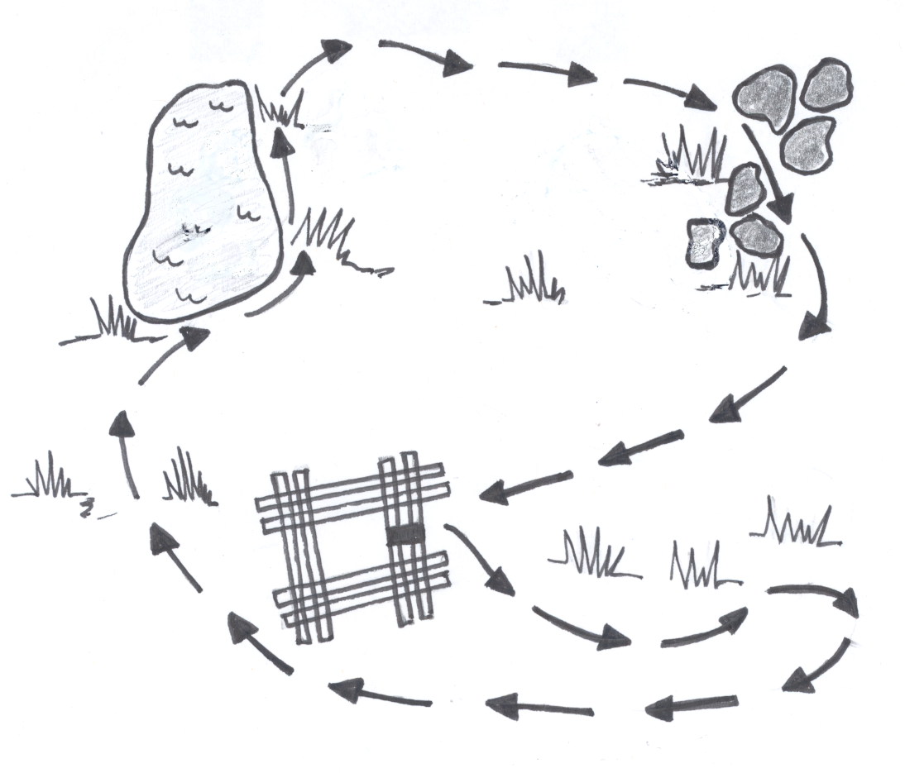
Brown felt pieces – rocks, areas of danger
Light blue felt piece – water area
Pop sticks or brown felt strips – sheepfold
Green underlay – grassed areas
Route of Good Shepherd

Carefully pack story materials into storage box and put on shelf. Ensure that children are watching so they know how to pack the materials away and where to find them.
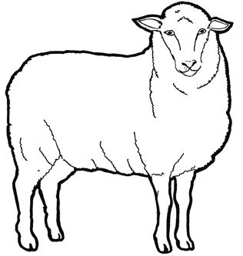
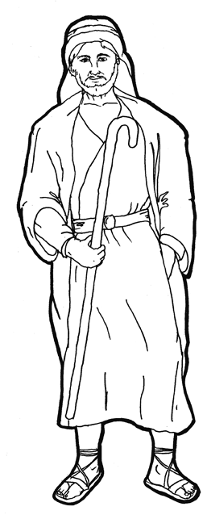
Good Shepherd

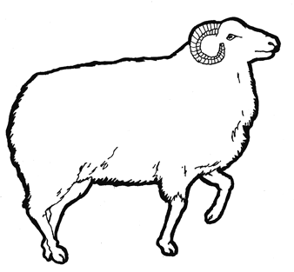

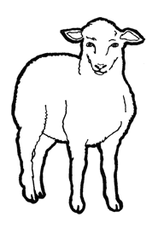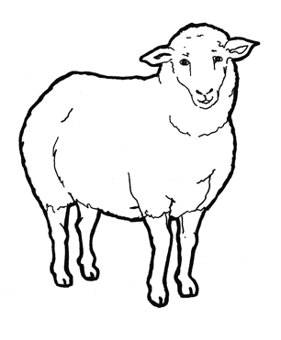

sydney

